**1963**

Dad paints the entire outside of the house, and much of the inside as well. He builds drawers, spades the garden, plants vegetables, sorts screws, polishes the car, installs light fixtures, hangs pictures, and even plants a pole. He appears to understand the finer nuances of home décor, and there is a lot of home décor-ing going on. Is this really my father? Mom plots her (much deserved) escapes by joining and joining and joining. Spotty, the new cat, gets a vacation, but the sewing machine does not. The girls get haircuts that release their inner curls. Alan is a pill, a tease, a mischief and a trial, and also, of course, a joy. “Percy” is Andy, and Andy is a tax deduction, which means that Dad is pleased.

**1-?-63- Sun 9:00 PM -** Dear Mother and Aunt Clara, I can’t remember for sure when I wrote last. Your letter came and the last card on Wed said you hadn’t heard yet. I was thinking I wrote a week ago Fri or Sat. As you know we’ve had the same cold weather you have had. It never got above 0 for one stretch of 36 hrs. Decatur is about 5 degrees warmer than Chicago, on the average, but this winter has sure seemed cold. I put some weather stripping around some of the doors which has helped. The snow hasn’t been real heavy but the streets have been slick at times. I was having some car trouble there for awhile but it was easily corrected, no charge, and since I’ve had no trouble through all the bitter cold. My service station is half way between here and work so I don’t worry any more about getting stalled. Not like Chicago out on the expressways.

The girls say “Thanks” for the napkins. Alan says he’ll take one sometime also ha! Ruth will add a note. We all went to church today. I haven’t missed now for several Sundays. Our choir is off next Sun. Our director, that Richard Hoffland I’ve mentioned, is also director of the Milikin University Choir and the’re on tour now through Missouri, Kansas and Oklahoma. Their home concert is this Fri night.

Ruth has a decoration committee meeting tomorrow night and nothing else this week but choir practice on Wed. Yesterday morning I ran some errands. Ruth went shopping and then we went to a party at Dr. Cavalitto’s (director of research) new house (3 yrs old but they just bought it) south of the lake. It’s around a $40,000 house, I would imagine. Afterwards we ate out with 3 other couples (fellows at work). Fri night I fixed the tension pulleys for the living room curtains. Tonight I put up a horse picture in Alan’s room. Alan has been quite a “pill” about drawing on walls with crayons. He just can’t seem to learn. The girls never gave us any trouble about writing on walls.

We went to choir last Wed night and Ruth had 1 or 2 meetings during the week. Fri night we all went downtown to pick up some orders and to leave a picture to be framed. I bought some new music for Ruth’s birthday. Fri night on the way back from downtown we stopped at Dr. Bill Stone’s (the intern here that I met in Chicago). He knew Dr. Geiger who was one of the 3 major men where I worked there in Chicago (Dr. Abood and Koketsu were the others). Dr. Geiger died recently during experimental heart surgery of some kind. Lucille (the colored lady dishwasher – you remember her I think) Elliott wrote us about it. I wrote Leo Abood a letter shortly after we came here and also a note on a Christmas card but have never heard from him. We stayed till about 11:00 at the Stone’s so the kids were pretty tired.

Your pill sounds like it has some diuretic in it (increased excretion of sodium). They use that a lot now for blood pressure and everything. As you say the best thing is to go to the Dr. regularly and then not worry and forget it. I can imagine you were cold. The new type furnaces have blowers which circulate the air and make it warmer. In your house all the heat goes to the ceiling and doesn’t get circulated. I can remember how cold it got. Glad your tooth work went OK. We never heard from Mr. Hilton. That was all very interesting about the drug stores. Sounds like a good thing all the way around.

Last Sun we took the kids to see the movie “Jumbo” and I put up our new 3 light fixture and new lights for by the fireplace. Mom adds: Thanks for the check. I used it for some much needed everyday shoes – a grayed brown suede oxford – which are good enough to wear shopping as well as around home. The girls, especially Lesle, were thrilled that Mommy got some new shoes. Thanks again!

**1-3-63 – Thurs PM -** I guess we’ve been kinda irregular with our letter writing because of the holiday season. I thought maybe we would have a letter from you today but I’ll go ahead with this so you may get it on Sat. If I mail a letter at work on Fri mornings you sometimes get it on Sat. I guess the postage rates go up before long. Alan is really at a cute stage. He learns new words all the time and is a joy when he’s good. When he’s irritable, on the other hand, he can be quite a trial. He had a nice birthday and says “thank you” for the presents. He got 2 wooden puzzles, a book, a big box of blocks, 2 shirts and 2 pants (We got him a dress outfit - using your money), and a little toy work bench.

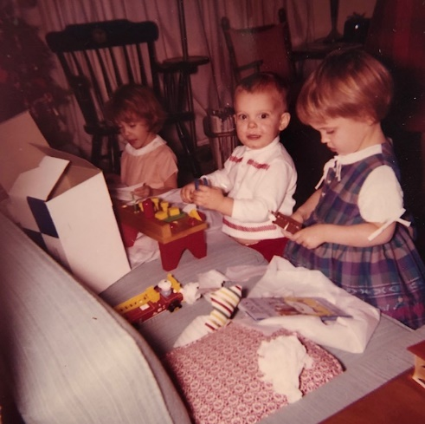

Alan with his toy work bench. Lisa in the dress she got for her birthday from Grandmother.

We had a nice birthday dinner for him and I hope I got several good color pictures along with the ones at Christmas. I’ll finish the roll this weekend and we’ll have a set of prints made to send on. You’ll get an idea of the inside of the house from the pictures.

We went to choir practice last evening. Ruth and Lesle were the only ones to go to church last Sun. Lisa and Alan had colds; Lesle was over hers enough to go – she is the one that is always so disappointed when she doesn’t get to go. Lesle has always been the most free of colds so this was one of her worst. Ruth has some tonight but I’m relatively “free” at the moment. We really can’t complain about sickness with our children, we feel we’ve been lucky with no major illnesses. We finally took Alan to an orthopedic man here (about the feet etc.) and he thought all he needs are pads in his shoes. He said Lisa looks OK, so that should finish off the leg and foot corrections. We all need to get started with a dentist before long.

It was nice you could all get out to see Uncle Clyde the day before Christmas and hope you had a nice time on Christmas day. Thanks again to both you and Aunt Clara for the gifts. The back on the piano looks real nice and the magazine rack has arrived and is fine. We’ll also get some Eagle bookends to fit in with things. I really enjoy having the leather bound dictionary which Ruth got me in the living room; it looks nice on the apothacary chest end table I got Ruth. We have moved the TV onto that maple chest (with 3 drawers) that we bought while we were in the apartment. The TV was on a metal stand with wheels which didn’t fit in very well.

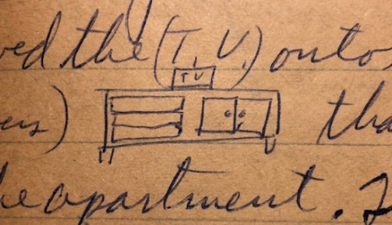

Eldon Laidig has been promoted to principal of a junior high school out in Arvada, Colo. (Denver suburb). He is my age and will probably be making about what I make now. They were in Oberlin for Christmas. The John Laidigs may be through here in Feb. on the way to Judy Laidig’s (their oldest daughter at KU) wedding in Lawrence in Feb. We’ll try to have our bedroom sorta finished by then. Our bedroom and the hall by the bedrooms is the only painting left to do upstairs. Last Sat and Sun I laid (Dad wrote ‘layed’ and Mom crossed it out and wrote ‘laid’) the interlocking rubber tile, alternating red and white rows, in Alan’s room. They were more expensive than ordinary tile, but can be taken up if necessary, and seemed best in an upstairs room over good wood floors. They go with his red and white stripped window shades. My next job is to put up the shelves in the kids’ rooms. We’re making plans now for what we want to do in the basement.

We stayed home New Year’s evening and took down the Christmas tree – much easier when the kids are in bed. The tree looked nice from the outside. The kids would have liked for it to stay up forever. Alan thought sure I must have taken it to the basement. I worked Mon and then had New Years day off. Watched football and did some reading and cleaning. We had the Hofflands (our choir director) over for dessert a week ago tonight. They just live a few blocks from us. They have young children who go to Mound School here by us. Mr. Laidig was in Denver recently to have his throat checked because of hoarseness. They said it was inflamed and didn’t think there was any cancer. He had a fall recently while working at his brothers which they didn’t think was do to slipping. Mrs. L says he just won’t slow up. That school job at Atwood has been pretty hard on him.

Ruth or I may have mentioned making Lesle a new red velvet dress. She finished embroidering a baby quilt for the Cormans (school friends) in Calif. She has started today on a baby quilt for her Dr. cousin (MD – son of the dentist – Earl Laidig in Danbury, Neb.) in Seattle. He’s 35 and just got married a year ago or so. Thanks again for everything and hope you’re all feeling more rested now. I know your diet must be a nuisance, but its for the best. Show to M.J. if you want.

**1-15-63 – Tues -** As usual I didn’t get this written when I thought I would. The last couple of days have been quite cold; its been down around 0 at night. We didn’t get the 4 inches of snow that were predicted for Friday night. We’ve had only a few inches all winter so it hasn’t been bad at all – although pretty cold at times. We were glad to have Aunt Clara’s “Thank You” note today. She mentioned receiving stationery. We are wondering if she received the Moore plate OK. We didn’t remember sending any stationery this Christmas.

I have a couple more pictures to take of the girls room and will then get them all developed and some sent on to Kansas. I finished putting up the shelves and drawers in the kids room this past week-end and Ruth painted them, we think they look real nice. The next thing is to get some folding doors for the closet in Alan’s room. The original closet doors are sliding and are not very convenient for his closet where we have his changing table. Alan seems so grown-up in his new brown low top shoes and some new boyish clothes. We also need to get a storm door for the door into the garage – it lets in quite a draft. We also need to get some weather stripping for some of the other doors and windows.

Ruth has several meetings this week. She’s on several committees now so is managing to keep pretty busy. Last Wed night we had our usual babysitter and went to choir practice. Thurs night we went to a church study group at the home of our organist (he’s on the staff at Milikin U.). They are studying the resolutions etc. of the General Assembly meeting of the Presbyterian Church. The subject that night was race relations. We invited them to our house for the meeting next month.

Sat morning we went downtown. Lesle got her first pair of shoes she’s had in a year – white and navy blue. She just hadn’t grown much, so we really got our money’s worth. Tonight after supper we went to the library, and then all went to a restaurant for ice cream. Alan was really thrilled, but they were all good. We hadn’t been to one since Alan could remember.

Hope you’re feeling OK and your diet is coming along. Why don’t you and Aunt Clara make plans to come visit? I’m sure you could travel OK with your eating if you had plenty of your medicine. What was the name of the medicine the Dr. gave you this time? We had a note from Aunt Margaret mailed from Texas. Had your card and letter. Thanks.

**2-10-63 -** Your black and white set is to keep. The colored ones are for you and Aunt Clara to look over and return. If you want any copies you can have them made there. They are quite expensive as you know. I’ll write more later we’ve been busy.

**2-5-63 – Tues AM –** Glad to have Aunt Clara’s letter and will probably have one from you today or tomorrow. I’m sure if you missed a letter that it was lost somewhere as I mailed. (sic) I haven’t been writing on the week but I know I haven’t gone over 10 day. It would have been the letter in which I asked you about the blood pressure medicine. We’re all getting over a round of colds, but otherwise are OK. I worked around the house all weekend and got some pictures up. It’s really looking nice now. Yesterday and today have been warmer and its a welcome relief. Aunt Clara mentioned coming in April. That sounds fine or anytime. I’ll write more later after I hear from you.

**2-?-63 – Sat 8:30 PM -** I’m in the bedroom where Ruth is working on our closet and sorting things. We’re gradually getting to the end of things upstairs although we still have our bedroom windows to fix shutters for. We’ll use the kind that have drapery material on them rather than louvre boards. We haven’t decided yet on the color for the bedroom walls. I finished the hall walls last Sat afternoon; they are the same color as the living room.

The kids were glad to have the candy box from Aunt Clara today. Our pictures to you folks will have to serve as our valentines for this year. We just didn’t get regular valentines purchased. We used your $2 to eat at the drive-in last Thurs night. That was the evening we had the church study group at our house. There were 18 here including the preacher and his wife. The group has been studying the pronouncements of the General Assembly of the Presbyterian Church; the last two times on segregation, housing, immigration, etc. I’ll lead the discussion next month on international relations. We’ll meet at the Dick Hofflands (choir director) next time. The organist (he’s on the staff at Milikin U like Dick Hoffland is) and several of the Milikin people are members of the group. One of the couples are Richard and Jackie Bennett; he is a chemistry professor and about my age. We had them out for dinner last Sat night. They have no children but she just had a miscarriage. He almost finished his PhD – didn’t get all his research done.

We were glad to have your letter and hope you had a nice time in Newton. Hope you got the pictures OK and as I said return the colored pictures and negatives after you have any copies made that you want. I had hoped to write before this but we’ve had one of busiest times. Ruth finished heming the living room curtains and made the curtains for the front door and patio door. We put up a display of pictures in the living room.

Mrs. L has been very sick with viral pneumonia and has been in the hospital for 2-3 weeks. She was still there the last we heard but they felt she was over the “hump.” She has always been susceptible to lung trouble. This is the worst bout of pneumonia she’s ever had; she spent 6 months in a TB hospital once.

We all rested this morning and this afternoon put the 2nd coat of white paint on the basement steps. That is the first job in the basement. Tomorrow I’ll put the stair treads down; they are little braided rugs and should look nice against the white background. Later this afternoon I went to the lab to inject some animals and then Ruth went to the library. The kids had to stay home since Lisa and Alan have had some intestinal flu for a few days. Not bad but enough that they haven’t felt too good and they have lost some of their appetite. They seemed better tonight.

Irv and Ruth Martin were to come over tonight but he’s been busy and felt he should study for his master’s oral exam next week. He gets his master’s from Milikin in Sacred Music and will go from here to jobs in West Virginia and then Oregon. They sing in our choir and we went to his recital some time ago. Tomorrow one of us will stay home with Lisa and Alan. The John Laidigs are supposed to stop by on their way to Kansas for Judy Laidig’s wedding at the First Methodist Church in Lawrence next Thurs night. It will be too bad if Mrs. L won’t be able to go; she’ll undoubtedly try to make it if the Dr’s OK it. We got them a toaster. Judy and Ron (he’s in engineering) each have 1 more year to graduation.

Next week Ruth has a meeting on Tues night. Since I wrote you last she’s had some of her usual meetings. I had a big report to write recently and that took some extra time. My work is going fine. I guess I didn’t mention my raise to $10,560 (from $10,200). It was based on the fact I hadn’t been here a year yet and is about what the others say the annual raises run. Considering the size of our company, the size and location of Decatur and my experience, I feel my salary is comparable to others in my field. We’ve gone to choir practice on Wed nights as usual. I’ll go over the clippings soon. Hope you’re all OK and glad your medicine makes you feel better.

**2-27-63 – Tues PM –** Everything is about the same here. I have a touch of cold and some hoarseness but haven’t had to miss any work. The last 2 or 3 days have been bitter cold (10 below last night) again after that mild spell. Maybe this will be our last real cold. We had our biggest snow last Sat. It was warm enough yesterday morning that the kids could play outside and build a snowman (with help). Although it’s been a cold winter we really haven’t had enough snow at times when it was warm enough for the kids to play outside much.

Yesterday evening we went downtown and picked out a card table and chairs. I had promised Ruth one for her birthday and we had ordered it 3 wks before that meeting we had here; we just got word that the one she wanted isn’t being made anymore. Except for company she’ll use it mainly for sewing. One of her next jobs is to make café curtains for the living room so there will be curtains across the bottom of the big windows when the big curtains are pulled.

We’ve been at home tonight. Tomorrow night is choir practice. Last Fri night Carol and Jack Duvall and their 4 children came in. They had taken a wks vacation back with his folks in Penn. and came by here on the way back home (Chicago suburb). He works at the airport there (O’Hare) and she and Ruth were early chums in Oberlin. They stayed till Sun afternoon and went to church with us Sun morning. That was about long enough together with the 7 children (6 pre-school) and 4 adults, although the children played well. We brought up mattresses and we slept on one in Alan’s room.

I went downtown Fri night and picked up a new toilet seat – the old one was in bad shape. Last week Ruth had meetings Tues morning and night, Wed night choir, and Thurs morning and night, 2 groups of AAUW, Womans Assoc, League of Women Voters. A wk ago Sun I stayed home with Alan and Lisa since they had colds. I got the basement stairs finished and they look nice. White with braided rug stair treads.

Your new pill (I think?) has some diuretic in it and that may account for some of your wt loss since you’ve had some swelling for several years. Your low fat diet would not allow any wt gain either. You’re probably better on the thin side as long as you check regularly with the Dr. and he seems to feel its best. Some fluid loss due to the diuretic – good for blood pressure – may pick up some fluid again later. Hope Aunt Clara and the folks are OK also. Let us know your plans for coming. The Laidigs will come Easter. Any time is fine.

**3-6-63 – Wed PM –** We just got home from choir practice. We have refreshments every other week after choir practice but it was not the time tonight. It has been rainy today and a little cooler but it has definitely been warmer and it will probably be spring before we know it. I may have to buy a new power lawn mower since the old one I bought for $10 from the Dahls didn’t work the last time I tried it.

Lesle says “Thank you” for the birthday card and future gift. Glad to have the letter with it and the one the other day about the trip to Larned. Sorry to hear that Uncle Clyde is getting worse. Lesle had a birthday party this morning – 10 kids and 5 adults were here. Ruth stayed up late last night to finish matching dresses for Lesle and Lisa. Grammy sent her a dress so along with yours she’ll be all ready for school. This afternoon Ruth took Lesle over to register for kindergarten. She will have to have a physical and dental checkup. Ruth finally went to the dentist yesterday. She has 2 future appointments for removal of a wisdom tooth (only one not impacted) and filling of some cavities.

This evening at supper Lesle had her presents from us and then she gave Lisa and Alan presents. I took some pictures. We ordered her a bigger tricycle which is in (Wards), but we won’t be able to pick it up until Fri evening. We have sure used our credit cards at Wards, Sears and Carson, Pirie Scott & Co.

We were home Mon and Tues nights and I’ve been working on my monthly progress report. Everything is fine although I hope to get a technician sometime. I’ve been given a great deal of freedom, about like a university, so that’s probably one reason they haven’t gotten me one before this. I’ve had some hoarseness and cold for over a week but haven’t had to go to bed yet although I’ve felt like it several times.

This weekend I may start working on the bedroom. I have to start reading for the study group a week from tonight. The Laidigs were planning to come Easter but I guess they won’t now. He has been sick some and the Dr. told him he must slow down. They both made it to Judy Laidig’s wedding in Lawrence and he got sick afterwards. He had symptoms of a heart attack but the Dr. couldn’t find any real damage. Mrs. L is driving him back and forth to Atwood each day and didn’t think they better come now. We all made it to church OK last Sun. We had a big anthem or I might have stayed home with my cold. I have some clippings ready to return. Glad you’re feeling better and show to Aunt Clara and M.J. of course.

**3-9-63 –** We were glad to have your letter today. Today was warm and windy but it turned cooler tonight. It rained yesterday afternoon and evening along with some thunder and lightning. Alan has been quite fearful of thunder and lightning but he was better about it yesterday. Ruth went to the contemporary living group of AAUW tonight. We were home last night. Tomorrow night is the Irwin, Neisler Credit Union dinner and then we’ll go to choir practice.

Last Sun morning we all went to church; our choir did not have to sing. In the evening we went to the Lenten service. There was a lady there to watch the children. No visiting Neisler salesman has looked me up. 2 or 3 wks ago they had one of their bi-annual sales training schools so he might have been there. There were only 8 or 10 of them, and they stopped by my lab on the laboratory tour. I didn’t have to give the talk I did at the last school; Dr. O’Dell gave it – he was sick the last time.

Everything at work is OK. I could use a technician under me to help with some of the routine things but they have given me a lot of freedom. The Chicago Medical School is one of the 3 medical schools around where I was. It has some Jewish money (?), I believe, and has a new modern medical science building. I went over there once with Dr. Abood; we talked with a man to see if there might be a place to work a year or two after I finished with Dr. Abood. I’m glad we didn’t stay any longer in Chicago.

I stayed in all last Sat. It was Lesle’s turn (Lisa’s turn the Sat before) to go downtown alone with Ruth and buy some saving stamps and some toy she picked out herself. They used savings from their banks. Alan is essentially “half-way” trained so we should be “free” of diapers before too long. Since I wrote last I went with Ruth to an AAUW dinner meeting to which the men were invited – dinner speaker. As I said, my leading of the discussion group went OK. We’ve been discussing pronouncements of the Presbyterian General Assembly and my subject was on international relations. I stayed home from work last Wed and Thurs AM and it gave me a little extra time to decide what I should say. Felt pretty well, but tired, by Thurs night. Hope you’re all OK.

**3-27-63 – Wed PM 5:30 -** We were glad to get the pictures today – they are the right ones. As we’ve thought all along I think Alan has a little more Laidig resemblance in the face; however, the back of his head is definitely “my shape” so I guess I can claim him ha!

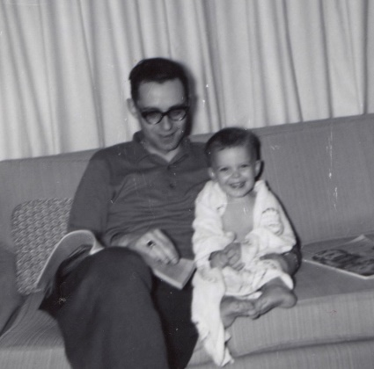

Daddy and Alan - March

Today was warmer again after a brief cool spell. The kids are all playing outside on the swing set. With the living room curtains drawn it is very easy to watch them except when they go out to the garden area. Ruth worked awhile in the yard last week-end and I replaced one of the clothes-line poles with the larger one we bought in Chicago. Its warm enough today to dry clothes outside. Our washer is still holding up although its getting noisy. I suppose we’ll have to replace it before long.

Glad to hear that Uncle Clyde and Uncle Archie are holding their own. The last letter from Oberlin said Uncle Edgar had a heart attack. He is Mrs. L older brother living at Norton (35 mi east of Oberlin). They drove through here on the way to Indiana last fall. He is a farmer and has been on the Kansas State Board of Agriculture and some job on the fair board. I know he usually goes to the state fair in Hutchinson. I guess Mr. L is feeling OK although the job has been hard on him since there is dissent among the school board and other problems have arisen. I don’t know whether they’ll come see us or not. Let us know about any of your plans for coming. I will have only 1 wk of paid vacation but may take 2 wks.

Tonight is choir practice. We’re working on the Easter music. Mrs. Hoffland (choir directors wife) and Ruth are good friends and they stop sometimes when out on their bicycles (with their kids). They live about 4 blocks south of us. We were home Mon and Tues nights. Ruth had a wisdom tooth out Mon and is just now able to do much eating. I had a sore back Mon from putting in the clothesline pole Sun, so we were both miserable on Mon. Ruth will have to have her other 3 wisdom teeth out. I had 2 of mine out back when I had that work done in Hutchinson.

Last Sun night we all went to the Lenten vespers again. We all went to church Sun morning. Last Sat morning it was Alan’s turn to go downtown with Mama to buy saving stamps and a toy with his bank money. Its good experience for them to get the idea of saving something. We were home the rest of the day except when Ruth took the girls to get new dress-up shoes. Last Fri night we ate at the drive-in and then all went to the grocery store (it was payday). Fast food dinners on payday, an enduring Smith tradition ☺ We were home last Thurs night. Last Wed night Ruth and I went to the Irwin, Neisler profit sharing dinner at the hotel and then left early to go to choir practice. We haven’t started working on our bedroom yet. Hope you’re all OK. I have the clippings almost finished.

**4-7-63 – Sun AM -** As usual, I have no real excuse for not writing sooner. I’ve had a lot of reading and writing to do the last 2 wks and I just didn’t get to it. We were home last Mon and Tues night. Ruth went to AAUW branch meeting last Mon night and was home Tues. We went to choir practice as usual Wed night. Thurs night we went to the last Community Concert program using the Hoffland tickets – they had to be out of town. It was a group of folk singers and was very good. We might get season tickets for next year. Fri night we ate at the drive-in and then went grocery shopping – it was payday. Yesterday morning we watched 2 of the Hoffland (choir director) children until noon when the college girl who lives with them was able to take over. Mr. Hoffland had to direct a chorus near St. Louis. We took the kids out and we all worked in the garden. I spaded some and Ruth helped the children plant some seeds. We’ll have some vegetables, as well as flowers. We both like some gardening and yard work; that is the first real spading I’ve done since my garden in Hutchinson when I was a boy. Yesterday afternoon Ruth went shopping and in the late afternoon we worked out in the yard some more. We read in the evening and watched some TV.

We’re just about ready to leave for church. The kids have been getting up real early since the days are getting longer, so they’ll probably be tired by the time we leave. There are Easter services next Thurs and Fri nights and then, of course, on Easter Sunday. Last Sat morning we took the kids to the dentist. Lesle had to have a check-up before school – hers were OK. They hardly ever eat candy so that helps. We all went to church last Sun morning as usual, as also in the evening. A small group from the choir sang in the evening. Mr. L has resigned from his job for the rest of the year. It’s probably for the best, but Mrs. L doesn’t know what she’ll do with him as she’ll try to keep him from doing any heavy work around the house. They will probably try to come before long since he has resigned. Uncle Edgar is getting along OK, I guess. Ready to leave. I’ll answer any questions later.

**4-15-63 – Mon PM -** Glad you could all be together for Easter and it was good to talk to you. Ruth called her folks Sat night and they are about the same as usual. They think they might come for Mother’s Day. Lesle is singing in the youngest choir; they have 6 rehersals and sing on Mother’s Day, I think. The weather has been a little cooler and more normal recently after that real warm spell. I spaded a bit in the garden tonight and Ruth worked some in the yard today. We’re taking our time with it but shouldn’t have any trouble keeping ahead of things since we’re here so much earlier than last year; we didn’t move over here till last July 7th you may remember.

I do have 2 weeks paid vacation since I’ve worked a year. The regular time is July 27 to Aug 11th, I believe. I suppose we’ll go to Kansas. We are home this evening reading. Ruth worked hard today catching up on the washing since the sump was partly clogged last week and she let some of the washing go. Tomorrow morning she’ll take me to work so she can go to League of Women Voters meeting. Sat afternoon we voted in the school board election. There is a mayor and city council election tomorrow but we don’t vote since we’re just outside the city limits; the line runs in the street you may remember.

Thurs Ruth has women’s association meeting at church and then in the evening the creative writing group of AAUW will meet here. “We” have started on our bedroom but won’t have it done by then. I haven’t started my painting but Ruth hired the Hoffland girl to watch the kids last Thurs and Fri morning while she removed varnish from the woodwork. It’s hard to do that and watch kids. Sat morning we went down and Ruth and I both bought new shoes. My last pair was before we left Franklin Park so I guess I deserved a pair. I softened the water Sat afternoon and Ruth stayed up late to finish Easter suits (matching) for the girls. She has one for herself which isn’t done yet.

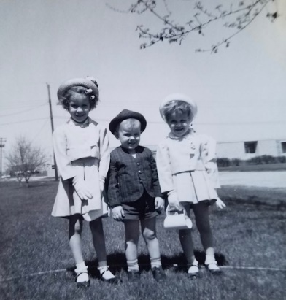 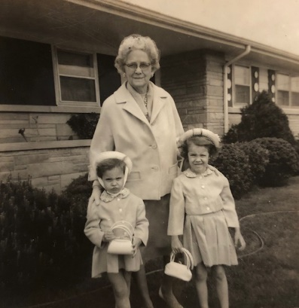 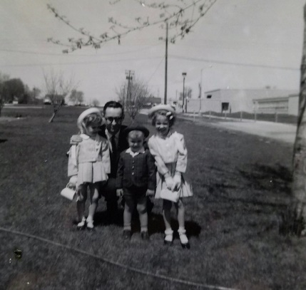 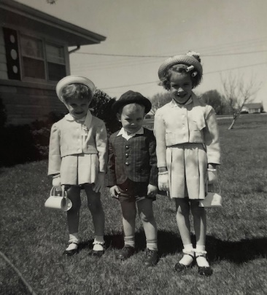

The Easter suits. No mention of Grandmother being in Decatur on or around Easter, but there she is.

These pictures are labeled in Grandmother’s handwriting as April 1963. Lesle appears to have curlers in her hair.

Sun morning we sang for both services. The kids held up pretty well and it was a beautiful clear day. We took a walk in the afternoon after naps. A farmer over a ways has sheep which we can hear and see sometimes. Last Wed night was a long choir rehersal. Thurs night was communion service and Fri night the choir sang for the Good Friday service. They have a lady at church in the evening to watch any children so we usually take ours. I guess those are the major things since my last letter.

Alan is almost completely trained and has stayed “dry” several nights now so we don’t have diapers for the first time in 5 yrs ha! He is quite a tease and gets into mischief and gets into to everything. Just normal, I guess. He loves the worms he finds when I spade in the garden. The meetings in Atlantic City that I went to the last 2 years start tomorrow. They’ll be in Chicago next yr so I’ll try to go then. We go to the Ice Capades at Champagne next Sat. Hope you’re all OK and let us know your plans.

**5-20-63 – Thurs 9:30 PM -** We’re resting at the end of a fairly busy Memorial Day so I’ll write this and maybe you’ll get this by Sat. Glad to have your letter this week and to know that everything is OK and that you had a good trip to see Uncle Clyde. Tell Mrs. Searl to tell Richard “hello” and find out if he’s active in magic. When I bring back the rest of my magic and we get the basement arranged I’ll fix up a corner to do magic shows for the kids. Lesle is old enough now that she could follow the tricks etc.

Thanks for the card and anniversary gift. We’ll apply it when we go out to eat tomorrow night. I guess the 6 years have gone by pretty fast and we’ve accomplished a few things. For this months progress report I’m summarizing my results for the last few months. Dr. Cavallito finally mentioned the possibility of my having a technician. It probably won’t be until after vacation. The company picnic is sometime in June.

Well, we’ve owned this house for a year now. It was June 1st that we bought the house even though we didn’t move over here until in July. I finally got the rest of the garden spaded and some corn planted. I need to get some fertilizer and then plant the rest of the vegetables. All the flowers that Ruth planted are already up.

Glad to hear that Aunt Clara passed her driving test. You may remember that we had to take tests in Chicago after we moved to Illinois. I mowed the yard today and worked around the house some. We cooked supper – corn, potatoes and hamburgers on the grill that Dr. Stone left us. It turned out pretty good for my first time. Last night we had our final regular choir rehersal although we’ll sing part of the time this summer. After choir we had coffee and then went over to another couples house – the Beatty’s. Bill and I played chess (my first game) and the women played Scrabble. Ruth’s first game since the game with you.

Ruth took the girls for professional haircuts. Lisa’s hair was wetted and put under a lamp of some kind and she now has curls all over – natural, I guess. Lesle’s hair is more curly too. Mom adds: (So-called “lamp cut” for naturally curly hair – Lesle had it too.) Back to Dad: We were here Mon and Tues nights. Last Sun we had our regular schedule except in the evening we went to a meeting at the church for people who had joined in the last year. Met several people. Last Sat night we went to that pharmacology section party for the technician who is leaving. I need to paint the guttering and edge of the roof here. We had that real cool spell here also. The kids remember grandmother, of course. Hope you’re all OK.

**5-23-63 – Thurs noon -** Ruth and the kids just got back from the library. The last few days have been real cool but a little warmer today. Glad to have your newsy letter and hope you had a good trip to Larnard. We had a nice choir picnic Tues evening. It was chilly but the kids had a big time. We were home last night as there was no choir practice. Went shopping 1st, however, and Ruth bought some new shoes (sneakers) for around the house. Ruth is teaching in Bible School later. They had a meeting at the church yesterday morning.

Last Sun we all went to church OK. Last Sat I mowed the yard and we cleaned up the house; in the evening Dr. Stone and family (that intern) came over and we cooked hamburgers on his outdoor grill which he gave us as they didn’t want to take it with them when they move. No particular news from Oberlin. Got the bedroom curtains up in the window frames and they look real nice. Ruth finished the chest also. She sewing some clothes now. We went to a surprise birthday party for the choir director, Dick Hoffland, Sun night. Got a little start on the vegetable part of the garden. Hope you’re OK.

**6-8-63 – Sat 6:00 PM –** I’ll get this off and maybe you’ll get it Mon. I drove down a week ago Thurs night to mail your letter but you apparently didn’t get it until Mon as you said in your letter written Mon that you hadn’t heard yet. Glad to have your letter. I’m writing a 4 months summary of my work, bringing it all up to date, when I get that done I’ll go through the rest of the clippings and get them returned. I don’t know our exact plan for vacation yet; whether we’ll go to Oberlin or Hutchinson first.

Yesterday and today have been our hottest days so far - 94. I worked a little while in the garden this afternoon but it was too hot to stay out more than a few minutes. The corn is up and beans and peas are starting to come up. I need to get out and plant the rest of the things. Ruth’s flowers need a lot of weeding. Softened the water this afternoon also. The kids are all excited about the little kitty we bought them at the Fun Fair this morning. That is an annual event sponsered by the hospital auxillaries to raise money. We went last year, also. They have rides, booths, etc. and people donate food and things to sell – like a fair. They rode some rides and we ate lunch there. The kitties and puppies were being sold by a local animal care group. It was only 50 cents. They named it “Spotty.”

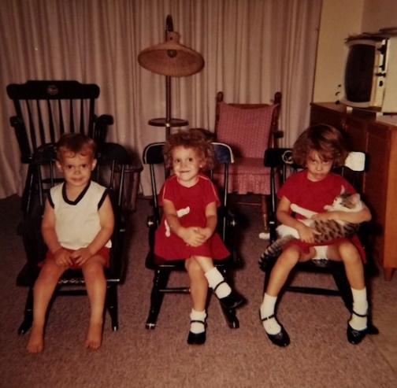

A picture with Spotty.

We went downtown last night and I picked up my new summer suit (2 pants) at Carson’s. Its the first real summer suit I’ve had since that light weight suit you bought me 6 years ago for our wedding, I guess. I’ve gotten by pretty well these years on a minimal amount of clothes. We bought it on our wedding anniversary a week ago Fri after we had eaten out at one of the nice restaurants. Thanks for the gift, we used it for the meal.

A week ago today I washed and polished the car more than any time since it was new. It still looks pretty good. Cooked hamburgers on the grill that evening also. Last Sun was the usual, I guess. Last Tues night our choir sang at the Illinois Synod meeting in our church. We had a 2-3 inch rain that evening and I had some trouble getting down to the babysitter’s house because of the high water. The drainage is not too good in some parts out here.

Thurs night we went to the Hofflands where there two girls and a neighbor girl gave a piano recital – 11 yrs and 9 yrs old. They had a lot of friends in. Last Tues Ruth led the singing at one of the Illinois Synodical ladies meetings. I guess that’s about it since I last wrote. I’ll get my report finished this week. Hope it not too hot for you folks. Our old air conditioner won’t fit in the kitchen window over the table. It won’t go in the living room since we couldn’t close the curtains. Hope you’re all OK.

**7-1-63 – Mon PM –** Hope the folks all had a good trip back and that Aunt Clara’s back is feeling better. Had your letter and clippings today. Tonight is a little bit cooler after some rain this afternoon. The last week has been our hottest spell. Last Mon night we took the kids downtown to hear the municipal band. Reminded me of when I played – some of the numbers were ones we used to play. They had a trumpet trio and our preacher, Rev Alton Kaul sang 2 solos (“Desert Song” and “On the Road to Mandalay.”) I used to sing that. After the concert we stopped at Sears and picked up their new catalog and then stopped for root beers on the way home.

Tues night we went downtown and bought an air-conditioner for the kitchen window. It helps considerably, but we need shades for the outside over the big living room windows and also a fan to circulate the air out of the kitchen. I probably mentioned that the old air-conditioner we had was too big for the kitchen window. Wed night we had a babysitter and then went to church for choir rehersal. Just the women practiced as only one other man showed up. We stopped for ice cream on the way home.

Thurs night I mowed part of the yard and cleaned the garage. Fri, of course, the folks got here in the middle of the afternoon and came by to see the lab. They got there just before I disposed of my animal. Fri night we took the folks out to eat at the Redwood (smorgasboard type) and not so expensive and easy with the kids. The kids were all good and we rode around some on the way home.

After the folks left Sat we took Lisa to have her shoes checked but she didn’t need new ones yet. Ruth bought a new duster and blouse. We rested and read the rest of the day as it was too hot to work outside in the yard. Yesterday we both sang at the early service and while the women sang at the 2nd service I watched the kids and took them to the park awhile. The Hofflands (choir director) are back for 2 weeks so we had them all over for dinner last night. Ruth did a lot of cooking in the afternoon. We don’t have much on this week. Tonight we went down to get the Wards catalog. Hope you’re all OK and that Aunt Clara and M.J. and Bill are rested up from the trip. We were sure glad they could stop.

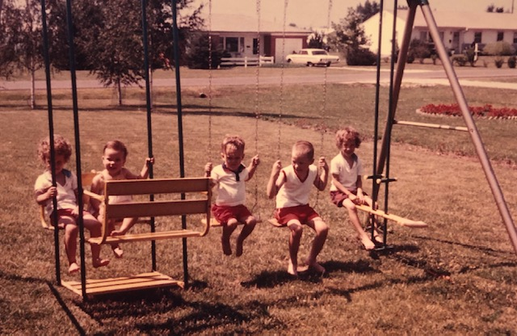

Lisa, Jana Kay, Alan, Jimmy and Lesle on the backyard swing-set.

The birch trees in the top left background are the corner of the property, and always seemed *so* far away.

**7-11-63 – Thurs PM -** I’ll write this now and we’ll mail this when we go downtown after supper to pick up an order. We were glad to have your letter and clippings. I suppose you got that batch of clippings that I returned some time ago. I have enough again to go over and return, I guess. We must renew our subscription to the Oberlin Herald since we get the Oberlin news that way. The news from the Laidigs: Deloris Musgrave (she just finished her sophomore year at Fort Hays) is planning to marry a Catholic in Aug. She was always such a strong Methodist but has changed, I guess. The Laidigs don’t have much contact any more with David and Dallas Musgrave who work in Denver.

I might as well tell you now that we’re expecting a baby about the middle of January. This one was planned and will just about “fill” our house. If we stay in this house we may have to expand it in some way in the future. For now, however, we’re quite comfortable. We’ll leave here 2 wks from Sat and go to Oberlin first and then on to Hutchinson the end of the next week. I suppose we should stop to see Uncle Clyde although he probably won’t recognize us.

The last few days have been nice and cool after that hot spell when the folks were here. The air-conditioner does a pretty good job when it’s not real hot. Hope it hasn’t been too hot for you folks there. This Saturday is the wedding of a girl who goes to Milikin University and who lived with the Hofflands. Alan has had the chickenpox since I wrote you last so we might try taking him to the wedding since he’s about over them. Ruth has been unable to get a baby sitter. The wedding is in the afternoon in the church chapel. I went to choir practice last night. The adult choir sings Sun and then for the last time the first Sun we’ll be gone. My work is going OK. As usual, there is always plenty to do. I won’t know about my technician until after vacation. Ruth has about got the flower garden weeded but the weeds are getting dense in other parts of the garden. We have lots of flowers from the garden now. Last week the girls played like I was Aunt Clara and Ruth was Grandmother, so I guess they remember you.

The insurance adjuster was out today and we will get some money for the hail damage on the outside walls. I’ll have to paint it after vacation. I took the girls in big church last Sun as Ruth stayed home with Alan (had chickenpox pretty bad then). Last Sat and Sun I stayed inside a lot to work on some things. It rained some Sat and was too wet to work outside. We stayed home the 4th (it rained in the morning) but went out later in the day for dessert. Haven’t done much else since I wrote last. Tell M.J. and Bill hello and we’ll see you soon. Alan says “Yes” a lot now.

**7-21-63 – Sun PM -** I guess this will be the last letter from here before we leave. We’ll try to go aways next Fri night after work, stop in a motel, and then on to Oberlin Sat so we can be there for Sun. We may not stay the full week at each of Hutchinson and Oberlin so we can have a little more time on the way back, possibly stopping in Kansas City and then coming back through St. Louis. We go on highway 36 all the way from here to Oberlin (Red and white 2 door 1957 Ford) and then I’m not sure which is the best way from Oberlin to Larned.

Ruth has a League of Women Voters coffee next Wed morning and since we won’t be here next Sun we won’t be going to choir practice Wed night (the last before Sept – the Hofflands are gone now to different choral clinics etc.). The last week has been very humid and hot although there was a nice breeze yesterday. Watched the eclipse some with 2 pieces of cardboard. The weather has been to hot and humid to work much in the garden but we still have flowers and should have beans, corn and have already had some radishes. I mowed part of the yard yesterday morning and will have to mow some more before we leave.

We all went to church this morning. Lisa went in the sancturary with us. We stopped at the store on the way home and then stayed in this afternoon although visited the wife of the organist who is in the hospital. This evening we went for dairy queens and then took a ride to see the corn, etc. The kids are taking baths now. Alan is broken out again and we think it is probably just heat rash but I suppose he could have the measles. We’ll watch him closely.

Sat morning we took Lisa for new shoes and then I took the kids to the lab to see some baby kittens, mice etc. I wonder if this was the time we walked past the dog lying motionless on his back on the stainless steel table, cut open from top to bottom, with his heart still beating, and blood dripping into a plastic bucket on the floor. I was not quite 4. Maybe it was a different time. Is this memory even real? “Spotty” was 2 or 3 months old when we got him so they had never seen a real tiny kitten. Fri night we had a babysitter and then Ruth and I went shopping and then to the movie. Thurs night we had a babysitter and Ruth and I went to meet at Gene Fishers house to decide on books for our study group this fall. The’re about 40 or so and he is director of chemical research (PhD chemistry) at A.E. Staley & Co. Last Sun was choir and the Hofflands were here. Can’t think of anything else. I guess this has been the longest either Ruth or I have been away from Kansas (about 16 months). Glad to have your letter and clippings this week. Sorry I didn’t get this written earlier. Hope you’re all OK and not to hot. See you soon. Thanks for the directions to see Uncle Clyde.

**7-29-63 – Oberlin Mon Afternoon -** We’re all relaxing this afternoon not doing much of anything. After the kids all get up from their naps we’ll take them over to the wadeing pool. It is right by the big swimming pool. We took them over awhile yesterday evening – it was somewhat cool then since yesterday was not real hot. It is a little warmer today. We were glad to receive your letter after we arrived here. We’ll plan to leave here as soon as we get around Thurs morning and then stop by to see Uncle Clyde on the way down.

We got away from Decatur about 8:00 PM – a little later than I thought we’d be able to since I didn’t have the new seat belts all installed. We have new seat belts, both for ourselves and the kids. We drove till about midnight and stayed in a tourist home in Monroe City, Missouri. We had a good trip on out Sat except for some heavy rain. Our windshield wipers didn’t work too well so I’m having them fixed tomorrow. We ate lunch in a restaurant (had brought along some things for breakfast) and then ate supper at a drive-in at Norton. We then went out to see Uncle Edgar and Aunt Dova in their new house there in Norton. The last time we were there they were just moving in. He’s the one (Mrs. L brother) who is active in state farm work etc. He comes to Hutchinson for the fair. He has been sick recently but is back working now. Yesterday morning we all went to s.s and church. Mr. L still teaches the adult s.s. class. Ruth and I helped out in the choir. We all just rested yesterday afternoon. This morning I went downtown and visited both drugstores. They are both remodeling and Addlemans is already looking much newer and better. Can’t think of anything else we’re going to do here. Hope you’re all OK and we’ll see you sometime Thurs.

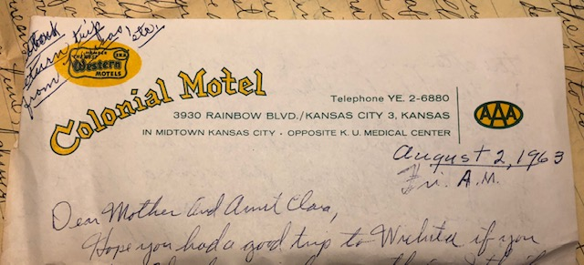

Stationery from the road.

**8-2-63 – Fri AM -** Hope you had a good trip to Wichita if you went. Thanks again for everything. I think we had a real good time. We left Hutchinson right after stopping at Aunt Clara’s and for some gas (the price was still down). We drove on to Salina where we stopped for some vegetables, drinks – we had already eaten the meat and some of the things you folks gave us. The Brown’s we wanted to see had moved to Burlington, Ks so we started on in the early afternoon. It cooled off on the way to Salina but was hot on the way to Topeka (4 lane most of the way). We stopped at the friends in Topeka and had supper with them. (He’s pastor of a new Presbyterian church there.) We drove on to Lawrence that evening where we stayed at a motel.

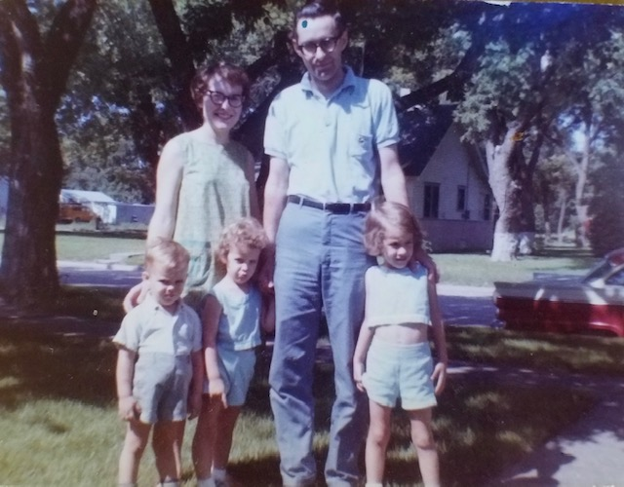

Vacation mode. There’s our red and white car in the background. Mom must be about 4 months pregnant here.

Wed morning we went out for breakfast and then to see friends (Ruths old roommate who has a new baby). We ate lunch and then in the afternoon I went to see Dr. Wenzel and the School of Pharmacy, while Ruth visited at the Presbyterian Student Center. We ate downtown and then visited Judy Laidig Moats (just married) before driving on to Eudora where we saw the Holladays. Stayed all night there and came on here yesterday morning. Ate at restaurant by med center yesterday noon. Visited Bob Legg (Ruths cousin). Ruth got her new material and then I saw Dr. Walaszek at the med center while the rest cooled off here at the motel. Yesterday evening Ruth visited Mrs. Moyes (preacher) who just had her baby. We’ll soon leave for Hannibal, MO where we’ll stay tonight and then on home tomorrow. Hope you’re cool enough.

**8-17-63 – Sat PM –** We were glad to have your card today. You were right we didn’t go through St. Louis. After Ruth found the material she wanted in Kansas City we decided to come on back a day early. We left Kansas City Fri morning and drove on to Carrollton, MO for lunch. As we were walking after lunch we happened by the drugstore of one of my classmates. I had forgotten that he was there. We all stopped, had a good visit, and his wife drove us around town awhile. We were later getting away than we thought we would be so just got as far as Monroe City, MO where we ate supper and stayed all night. The next day we drove on to Hannibal where we stopped at the Mark Twain house and then had lunch at a drive-in. I think I stopped at the Mark Twain when I was a boy, on one of those trips to Wisconsin. We drove on to Springfield where we had Dairy Queens and then on home, getting here by supper time.

We missed church last Sun but will go tomorrow. Haven’t done much today. Had the car in for an oil change this morning watched a ball game on TV this afternoon and finished mowing the yard that I had started a few days ago. It has been cool fall like weather ever since we got home so it almost seems like summer is over. The weeds had grown up in the garden but we’ve had some vegetables and there are still lots of flowers. They have made a road behind the school and opened our little dead end street so parents can drive on up and unload their children nearer the school. We’ll probably have more school traffic because of this. Ruth is going to make Lesle some more school clothes. The Laidigs went to Denver after we left and Mrs. L has had to return recently after Danny tipped over the tractor on Uncle Floyd’s (Mr. L’s brother – farm near Oberlin) farm where he was working for the summer. They sent Danny to Denver after he broke his arm and shoulder pretty badly. Deloris’s wedding is shortly and the John Laidigs will be there later this month. We had a letter from them saying they might be through here next Sat. Glad you made all your trips OK. You’ll have to hire a chauffer to help in the driving sometimes. Tell M.J. and Bill hello.

**9-1-63 – Sun 5:30 PM -** The kids are all up from their naps and we’re all here on the couch so I’ll use this time to get the weekly letter off. There’s a good family movie on at one of the drive-in movies so after supper we’ll take this down to the post office and then come back to the movie. It’s been about a year since we all went to a drive-in movie.

We all went to s.s. and church this morning. Lisa decided she would like to go to “big” church so she came in with us. She was real good although it’s still kinda hard keeping both girls quiet for a whole church service. Today was the last summer schedule service – only one service at 9:30. Next Sun we go back to the 2 services with the adult choir usually singing at the 2nd service. I guess we’ll have choir practice this Wed night. After church this morning we came home, changed clothes, and went back to the park for a picnic lunch. It was cool in the shade. We saw the ducks, bears and the kids played awhile before we came home for naps. Glad to have the letter from Mother this past week and to hear all the news from there. Our weather has really been nice since we got back from vacation, only a few warm days and several cool fall-like days. Hope your weather has been cooler, also, after that real hot time when we were there. My work is about the same, and hadn’t piled up after I got back. I finished some work on cats and will go back to working on dogs for awhile. I’ll be off work tomorrow, of course, since it’s Labor Day. We’ll probably labor a little around the house doing odd jobs ☺.

Our new stereo phonograph finally came last week so we now have record and radio music, we had been without for some time. Its Early American style and we put it on the right side of the fireplace. It has the new FM radio stereo which is real nice. I finally got some paint so I can get started painting the outside of the house. We had some hail damage or we might have let it go another year. I should fertilize the lawn this fall. The cat stood the trip fine. We took the cat?! A lot of cats get car sick so I guess we were lucky. We practically suffocated him in the car some of those hot days. I washed and polished the car yesterday afternoon so it looks almost new again. We have the piano tuner coming soon. With Ruth doing a lot more playing recently it needs to be kept up in tune about every 6 months. Hope Jimmy had a good visit with you folks and hope you’re all OK. Lesle starts to school this week so we’ll soon be as busy as ever. Lisa is looking forward to her birthday. Congratulations to Bill for their citation.

**9-8-63 – Sun 7:00 PM -** We’ve just finished supper after a relaxing Sun afternoon. We all had naps and then the kids played real well after getting up from their naps. Lesle got to go without a nap yesterday since she will have to go without when school starts. She is the type that still needs some daytime rest or she gets too fussy. We all went to s.s. and church this morning. We have one more Sun of the single early service before choir and the 2 services start again. The last few days have been a little warmer after that real cool spell – we’re not complaining, however. I mowed some yesterday and this morning after church. We’ve had some rain and the yard has grown real fast. I need to wash our dirty car next. Had to have about $40 worth of work on the car this last week. It was something that could have gone out during the trip (would have caused us to stall) so I guess we were quite lucky and didn’t get stalled out in the middle of nowhere.

Danny Musgrave (I think I wrote that he tipped the tractor over on himself) is back in Oberlin now. Deloris’s wedding is next and then the John Laidigs will be there about Sept. 3rd. They stopped by here yesterday afternoon on their way to see Judy and Ronnie in Lawrence first (we stopped to see them). They’ll see her folks in Topeka and then see Eldons in Colorado as well as the Oberlin folks.Mr. L says he may sell United Funds (like you have) if he can pass their exam. Last Sun (I wrote a week ago last night) we made it to church OK. It rained and we stayed in the rest of the time. Haven’t done much else this week except have the car fixed and we all went grocery shopping Fri night after I got payed. Glad to have your letter and clipping and to hear the news. I wonder if the Lesters were in Bloominton, Ill. Thats only about 30-40 miles from us. The kids have enjoyed their “new” chairs. They make trains, carriages, etc. Hope its been cooler there and that you’re all OK. I haven’t set up the “floating lady” trick for the kids yet.

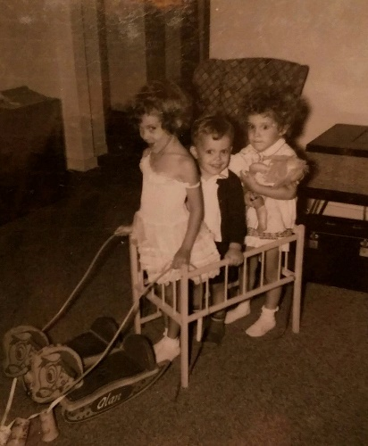 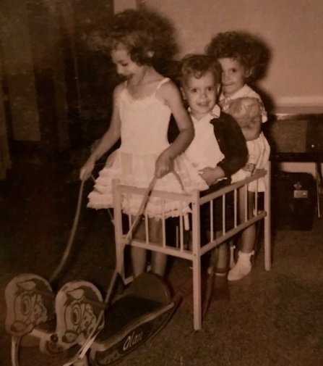

Not the “new” chairs, but here we are making a carriage with the rocking horses from Grammy and Grandpa.

**9-11-63 – Tues 8:00 PM -** Meant to get this off sooner, as usual. I’m sitting here listening to my new stereo record which Ruth got me for my birthday. All of our old records are the mono type so from now on we’ll get the stereo ones. The old records will all play, of course.

Ruth was gone to a League of Women Voters meeting when your package came so we’ll have to have them deliver it later. Lesle is enjoying school fine. Ruth got that one dress finished in time for the first day and now has one like it almost finished for Lisa. One of her next jobs is to cover great grandmothers chair with red. We may get a red seat-cover for my chair to add more decorative red to the living room.

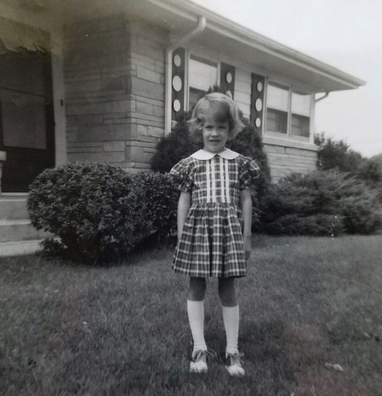 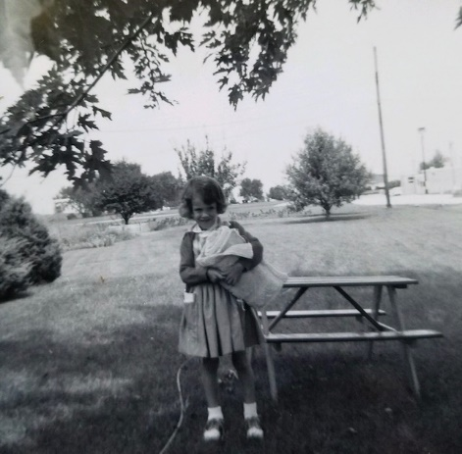

The picture on the left is labeled “First day of kindergarten.” The one on the right says “First real day of school.”

Everything is about the same at work. At the end of this month I’ll write a summary of my last 4 months’ work. Lisa had a big time on her birthday yesterday. I took some pictures which I’ll send sometime. I finished that other roll and left it today to be developed. I’ll send them on when they come back. We got Lisa a Tiny Thumbleena doll – you wind it up and it moves just like a real baby. She had asked for it several times so was really thrilled. She gave Alan and Lesle some puzzles. She’ll have a party next Sat morning with some of her friends.

This Thurs night Ruth is having the creative writing group of AAUW and next month we’ll have the church discussion group. Ruth thought it would be best to have them now rather than around Jan. Sorry to hear Aunt Clara was down a bit, but it sounded like she was right back up doing things. The last few days have been a little bit warmer but you can still tell fall is on the way. Tonight I mowed a part of the yard, did some painting and put up one of the front screen doors that Ruth had painted. I think I told you that we’re changing the green to oxide red. The green was faded and I think I like the red as well or better. Its a fresh change anyway. I’ve just about got the front (east) side done but of course, still have the other sides.

We went to the first choir practice last Wed night and will go again tomorrow night. Last Sun the choir sang for the first time. Mr. Hoffland was back. I painted Sun afternoon, and then in the evening we went to the Hofflands for watermelon. Last Sat morning I painted and in the afternoon we had a baby sitter while Ruth and I shopped downtown. I started the painting on Labor Day. Can’t think of anything else. Hope you’re all fine. Mrs. L wrote all the details of Deloris’s wedding. They can’t drive here until Nov. You come when you can. Mr. L has hernia surgery tomorrow.

**9-18-63 – Tues PM –** Glad to have your letter today and your card earlier. Glad you’re all feeling better. Lesle and Alan had a little bit of intestinal upset but didn’t get clear down. Ruth went to contemporary living group of AAUW this evening and I haven’t done much of anything. I painted some of the trim just before she left but it gets dark so early now that you can’t get much done in the evening. I’ll have to do most of the painting on the weekends. I doubt if I’ll drive down to mail this tonight so you won’t get this letter as soon as I thought you might. Tomorrow night is choir practice and Fri night we’re having Harold Kraus and his 4 children over for supper. He is a chemist and his wife has left him. His birthday is the 21st so we’ll have a joint birthday dinner. Last year we had another fellow from the lab over who also has a birthday on the 21st.

Lesle seems to be enjoying school and it sure makes it easy for her to get there since we live so close. She brings home a picture or something about every day. She gets more tired of course, so we try to have the kids in bed by 7:30 or 8:00 since they’re always up by the time we are in the morning. I got some of the snapshots back so will send them on soon. I may not have enough stamps to send them in this letter. It’s nice Mrs. Searl is back so she can help with the trips to Larned and its good you all have things pretty well finished in Wichita – I think Aunt Clara did the right thing by giving the house to the church.

Yesterday evening I painted as late as I could. I’ll run an experiment at work tomorrow and then start writing up my last 4 months’ work and try to have it in around the first of the month. Last Sun morning Lesle and Alan didn’t feel so good so I stayed home while Ruth took Lisa to church. Ruth had to sing in a short quartet part. I painted Sun afternoon. The piano tuner was supposed to come today but didn’t show up. I sure enjoy the new radio phonograph.

The AAUW creative writing group came here last Thurs night and it went off OK. I stayed back in the bedroom. Last Sat morning was Lisa’s birthday party which went off OK. I painted in the afternoon and then we went to the money-raising Mardi Gras carnival over at the school. We ate supper and took a neighbor girl with us. We took her back home and stayed awhile and visited with her folks.

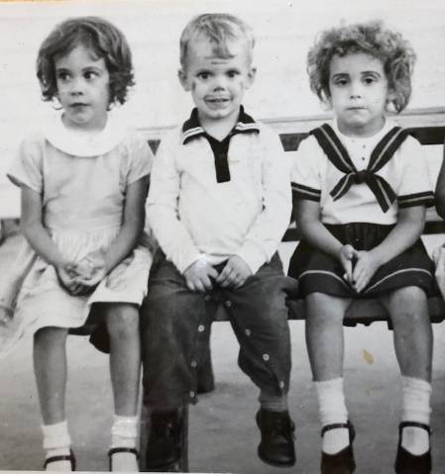

This picture is not labeled, but was possibly taken at the Mardi Gras carnival – or maybe the Fun Fair back in June.

Today has been warmer more like summer but it won’t last. Mr. L’s operation went OK. Ruth called them the next night. Ruth had her regular check-up today. Her back hurts some so she should sit, and walk a certain way. That is interesting about Gene Stucky’s new job. He’ll probably like it better and won’t have to work such long hours. Haven’t watched TV much since got phonograph. Dr. McCoy was the eye Dr. I went to. Last week went to choir practice on Wed night and had Lisa’s birthday dinner on Mon night. Mom adds: I don’t know if you could do a big quilt or not, but if you had the front and back well fastened together I don’t see why you couldn’t. My frame came from Sears.

**9-30-63 – Mon PM -** I hope the phone “took care” of the time between when I have been writing recently. Thanks to both of you for the birthday gifts. I’ll use part of it to buy a red seat cover for my chair. I’m not sure about the rest of it but I could use another pair of trousers. The kids each gave me a new shirt and Ruth gave me a new red sweater and stereo record. I have a black sweater (button) but it is getting worn out. Ruth had fixed a nice dinner for my birthday and we all used the good china and silverware. We could use some more place settings of china and silver, I guess, since we don’t have enough for when we have company. We had that fellow from lab (his wife left him with 4 children – he hires a housekeeper) over for supper a week ago Fri night and I thought that would be all the friends in for my birthday, but Sun night Ruth surprised me by having the Hofflands and Jensens (he’s an engineer for General Electric and Ruth knows her pretty well – they don’t live far from here) in about 8:00 PM. I had thought earlier in the day that she might surprise me, but by 8:00 I had taken off my good clothes (we ate out at that Redwood restaurant - where we ate with Aunt Clara and M.J. and Bill) and had decided that I was wrong.

Had a birthday card and note from M.J. and Bill – tell them “thanks.” Ruth had League of Women Voters last Tues morning and Wed evening we had the Neisler fall picnic out at a Danceland place. The fall one is where they have their beer. We left early, came back to get the babysitter and then went on down to choir practice. Thurs night we went to the organist’s house for the first meeting of our small discussion group. The assistant pastor at church started us on a little book about theology. We’ll meet at our house a week from Thurs and then every month after that through the winter at various people’s houses. A week ago Sat and last Sat I did quite a bit of painting. I’ve put on 5 gallons of white and it will take about 1-2 gallons more to finish; that’s beside the trim on the front which is finished and the guttering which I have to do yet. I started painting 4 weeks ago today (Labor Day) so I guess I’ll make it before it snows ha!

We may go downtown tonight - Ruth wants some better shoes to carry the added weight and a new purse to match. I need to get some paint and to buy some legs for the kids bookcase (to make it match the girls’ chests). Today Ruth washed and ironed the curtains in the girls’ room. The basement is messed up again (need your sorting ability) but I won’t start there until after I finish painting the house and making some shelves for Alan’s room.

Take your time on the pictures. Haven’t gotten the others yet. I sure enjoy the new radio phonograph. The piano tuner never showed up the other day but I suppose he’ll call soon. Got my report finished at work and nothing different there. Hope you’re all the same and come see us when you can. Deloris Musgrave (just married!) is expecting a baby about the time we are.

**10-?-63 – Tues PM –** Grandmother dated this letter Nov. 12 – but I think it goes here. **–** Dear Aunt Clara and Mother, I’ll write this before going to bed and mail it in the morning at work. I was glad to have Mothers call this evening and I’ll start checking on the package tomorrow. I should have started sooner. Thanks so much for the birthday gift. We went out this evening and used some of the gift money to buy a red cushion for my black “captains” graduation chair. It makes a nice contrast and now Ruth will need to make the red cover for the other chair that was great grandmother Ruth’s.

Hope you have a good trip to Larned tomorrow. I suppose Mrs. Searl will go along again to help. Tomorrow night is choir practice and Thurs night we’re having that church discussion group here. Should be 10-16 here – all couples. This next weekend, if the weather’s good, I should just about get the house painting finished. After that there will be inside jobs, as you always have when you own your own house and even when you don’t, I guess. The weather has been warm and dry (driest Sept in 7-10 years) and good for painting. We’ve had to water.

Last evening we ate at the drive-in and then did some shopping before coming on home. We’ve let the cat out some and has always come back, but it has been fighting some with another Tom-cat so we have to watch it. Last Sun was our usual church schedule. Have a good choir again at church. I painted a little Sun evening. Last Sat morning I went to the dentist for the first time in 6 years. He filled 2 cavities and on a later appointment will fill another and put in Mom adds in later: (put on an enamel cap) Back to Dad: -a part of a tooth that came out. Ruth has some more dental work later, I guess, also.

Last week was choir practice Wed night; we stopped for coffee at the choir directors afterwards. Thurs night Ruth went to AAUW and Fri night we had my “boss” Dr. Cavalitto over (his wife also). Wed AM – I can’t think of anymore news right now. Thanks again for the present and hope you had a good trip today.

**10-9-63 – Wed PM –** We’re just ready to start to choir practice. I called the post office today and they said there was no package there for us. He said you’d have to start the tracing from there. He said we would have had the other one delivered by now or had another notice if it had been there. Too bad, but maybe it’ll turn up. No more news since the letter to Aunt Clara. Hope you had a good trip today.

**10-17-63 – Thurs 6:30 PM -** Glad to have your card today and to hear the good news; I guess we were lucky. Also glad to have your letter earlier. Ruth is going out to AAUW creative writing group tonight. That is the group she is chairman of. They have been largely older ladies but are trying to recruit younger members. Tues night Ruth had the contemporary living group here at our house. There were 32 here (!) (just about maximum capacity for this house), the principal of Eisenhower High School talked to them about the new science curriculums. I had my usual trouble keeping the kids in their beds; this always happens when Ruth has a meeting here.

Hope you had a good trip to Wichita and got everything finished. We went to choir practice last night. We sing at the early 9:15 service this Sunday and then we’re having Don Pettit, the assistant choir director who is also a Milikan University graduate student, over for lunch. At 4:00 we’ll all 3 go to the Methodist church for the Reformation Day service choir practice. We’re helping in a choir from various churches.

I have some more painting to do this Sat if it doesn’t rain. I got the walls all finished but still have some trim to do. I’m not looking for rain since we haven’t had any for weeks. I guess they had rain some places in Ill last night. It has been pretty warm most of the time also although it cools off quite a bit by morning. Last Sun was our regular schedule in the morning. I painted some and softened the water in the afternoon. Thanks for returning the pictures. I’ll send the colored ones on soon. Haven’t heard from the Laidigs for some time, but assume they got home from their highway 83 trip to Texas and Mexico recently. Last Sat morning Ruth took the girls down for haircuts. Lesle is out of school today and tomorrow. Today the teachers visited industries and business men went to school. Ruth is going.

**10-27-63 -** Glad I found you by phone Sun night and it was nice to talk to Aunt Clara and M.J. also. Did you go to Manhatten? - you may have said or you’ll probably write the details. Today is our first real cold day and it may freeze tonight. I dug up some gladiolas before supper. Still have some trim and gutter painting to finish; haven’t done much the last few weekends. A week ago Sat I did clean up quite a bit in the basement. I moved the old brown rug (had it in Kansas City at the house up on the hill) from the side with the washing machine over by the basement stairs for the kids play house. I moved the green rug over to the washing machine side and fixed the magic and beds on it. I might paint down there some time.

Haven’t heard recently from the Laidigs since we heard that they got back from the Texas trip OK. Not so much on this week. Ruth has the refreshments after choir practice Wed night. Yesterday morning was our regular schedule - Reformation Sunday and had a church meeting afterwards. It rained some and I softened the water in the afternoon. We went to the reformation service right after I called you folks and then went to the Hofflands afterwards. Another couple, the McGeouns, were there also. We’re sorta starting a little social group that will get together at irregular intervals to do most anything.

Sat morning we took the kids to see the Miliken U. homecoming parade. I painted a little in the afternoon and we were home in the evening. Last Fri night I went down to Les Chafity’s (at lab) and watched the Illinois-UCLA football game from Los Angeles. It was played in the Coliseum. Mom adds: The kids (especially Lesle) are excited about Halloween. Each one has a pumpkin which Carroll carved tonight. They’ll dress in their clown outfits Thurs night and go trick or treating just to the people we know. Carroll will get a porcelain cap on one of the two teeth that could use one Wed morning. He had the preliminary work done last Mon. The school workshop study group of League of Women Voters will be here that morning too. Back to Dad: Glad you had a good trip to Jetmore and Larnard. (Larned?)

**11-6-63 – Wed PM –** I meant to get this off yesterday but didn’t make it. We were glad to have your letter yesterday and to hear the latest news. The Laidigs plan to come visit us around the 15 or 16th. As you know they had planned to come earlier but various things came up. I guess the’re both feeling pretty well. We had a letter today from Don Musgrave, the one that teaches school at Eskridge, Kansas. He is about Ruth’s age and is single. Deloris, the one who just got married, is in Manhatten where her husband is in school. Delbert is married and in the service in Germany. Danny at home, is the one who broke his shoulder - I guess he’s getting along OK. Dave and Dallas (the one who is separated – we attended his wedding in Minneapolis) are both working in Denver, Colo.

Tonight is choir practice. We’ll drive by the post office afterwards to mail this. Last Wed night Ruth and another lady had the refreshments following choir practice. We’ve already started practicing the Christmas music. Last Sun we had 31 in choir which has been about maximum for us this year. Tomorrow night Ruth goes to AAUW branch meeting. The last few days have been colder and rainy. We needed the moisture, however, as Illinois has been very dry this year. We were home last night. Mon evening we went to a house for a neighborhood meeting about our pledges. I’ll try to increase ours for next year. I’ve been pretty busy at work trying to write some reports, etc. One of the regular technicians, Pete Luna, (first mention of a very familiar name) will help me on Wed and Thurs. He came in today and was a big help on what I’m doing. Everything else at work is about the same. It will take more time yet to tell how some of our research compounds will turn out.

Last Sun morning was the regular schedule. We were home in the afternoon until going to the Hoffland’s for Elsa’s birthday party (4 yrs). After supper at home we went back by for them and we all went to the church, along with the 7 children, to hear a bass singer who travels around and presents his testimony through his music. Last Sat I cleaned the garage and we were home in the evening. I have my final (4th) dental appointment this Fri. Will probably be $70-100 all together. We took the kids trick or treating in the car since it was raining. We didn’t have very many here. Glad you’re all OK.

**11-13-63 – Wed 6:30 -** I have some time before going to pick up Laura Brenneman, our regular choir night babysitter, so I’ll start this now. I guess I wrote you a week ago tonight. Tomorrow night we have our monthly discussion group. We have one negro couple who are members and it is at their house. I guess they had quite a bit of trouble finding a house like they wanted. He is an insurance man and is the local NAACP president. They are not members of our church but have come to the discussion group several times.

Fri is a lecture in Chicago there at the University of Ill., Dept. of Pharmacology. Its related to some of our work here so I’ll go up. I’ll fly up in the morning and come back on the train in the afternoon. It’s in Dr. Sherrod’s course there; Dr. Sherrod is our consultant. I’ll go over and see Dr. Abood if he is there. I haven’t been back there since I left.

The Laidigs should get here sometime Sat but we don’t know when. We don’t know how long they will stay or whether they may drive on over into Indiana to see the relatives. I finished my reports at work so don’t feel so rushed there this week. I started going through your clippings last night. We were home Mon night also. We went to the antique show last Sat afternoon and bought 2 mortars and pestle’s for our living room. Last Sun was the usual schedule. I softened the water and painted some in the afternoon. It was warm on Sat and I painted some in the morning. I have some guttering left but got everything done on the side facing the street. It has been colder the last few days and is quite cold and windy today. My next job is to make some drawers for Alan’s room.

Glad to have your letter yesterday. Lesle had her first cherub choir rehersal last Fri. This Fri the girls have eye check-ups. I went to the dentist last Fri and got my tooth capped. I still have one more appointment to finish up. Yesterday afternoon we went over and visited Lesle’s class at school. Hope you’re all OK. Alan thinks he will be going to school any day now. I don’t think the Laidigs will stay till Thanksgiving.

**12-1-63** – The kids are all asleep now so I’ll write this and will mail this when we go down for the advent sing later, at the church. Our weather has been colder the last few days but is a little warmer today. We had a little snow, our first, Fri night and yesterday morning. Ruth will enclose some gift suggestions for the kids. Lesle still has some cold or flu and doesn’t yet have her usual energy back. The other 2 kids have had some runny noses but have felt much better than Lesle. There was no school last Mon because of the assasination, but she also missed the rest of the week; there was no school on Thurs or Fri, of course. I hope she feels like going tomorrow since she does love her school. Ruth stayed home this morning with Lesle and I took Alan and Lisa to church. If Lesle feels like it we’ll all go to the advent sing tonight. The adult choir will sing and there will be refreshments etc. The kids will sit with a girl we sometimes use as a babysitter.

We stayed home all day yesterday not doing much of anything different than usual. I’ve set up the magic in the basement and have showed some tricks to the kids. Fri night Ruth did the grocery shopping. Tues night Ruth had to present their report on school financing to one of the League of Women Voters meeting. Wed night was that union Thanksgiving service at our church for which our choir sang. We had regular practice afterwards. Last Thurs we went to the Hofflands for Thanksgiving dinner. The McGowans were there also. We stayed till after supper and I called you after that.

Can’t think of anything special we did last week-end, other than watching TV etc. As I mentioned over the phone the Laidigs came back through here that Sat and I left Mon morning. We played Chinese checkers that Sat night and Scrabble Sun night with them. Fri night we did go ahead (day of assasination) and have the Hofflands and McGowans over as we had planned previously. The McGowans brought some slides taken in Europe. I remember the Texas trip some - I think we took a bus between Fort Worth and Dallas. Glad to have your letter and know you had a nice Thanksgiving. Kids still fussy with their colds. May buy a humidifier for the furnace. Running the vaporizer now.

**12-8-63 – Sun 2:30 PM –** Today is colder and snowy; it snowed some last night, also. Yesterday was quite warm. The choir sang at the early service this morning so we had to hurry more than usual. Alan didn’t want to stay in his class since it wasn’t his regular late service teacher. He got along OK, however, and the teacher said he was the only one that followed instructions. This afternoon after the kids get up from their naps we may go down to the afternoon performance of the “Messiah.” It’s being performed by the Millikin chorus and orchestra (includes a lot of students) at Milikan University. Dick Hoffland will direct. They have another performance tonight.

I softened the water this afternoon. Yesterday afternoon while Ruth went to the branch meeting of AAUW (Dick Hoffland had some student directed singing groups) I cleaned the garage for the first time in several years and sorted all the screws, nails, etc. Yesterday evening I rehung the girls drawers on the wall. Kids had climbed on them and broken the wooden wall brackets. I put up metal wall brackets which will hold more weight. It was guest children that climbed on them.

Yesterday morning we mailed 2 Christmas packages of candy and cookies. Ruth did a lot of baking last week trying to get things done early. Lesle missed school last week until Fri until she finally felt like going. We had the Dr. look at her on Mon and he said her lungs and ears were clear. It was about the longest she was ever sick. She gets quite fearful and didn’t eat a thing which made it harder for her to get rid of it.

Dr. Sherrod will be down from Chicago tomorrow to consult with us. I want to talk with him as much as I can. Everything else at work is about the same. Pete, the fellow that works for me 2 days a week is taking his vacation the last 2 weeks of Dec.

Last Sun, even though Lesle didn’t feel too good, we all went to the Advent Sing. Sheila Smith, a girl we’ve used as a babysitter sometimes, sat with the kids while we sang in the choir. Mr. and Mrs. Hoffland directed several of the choirs. The adult choir served Wassel (a drink) and cookies to the audience. Ruth had a meeting Tues night and we went to choir practice Wed night. We were home Thurs night and I went downtown and picked up some orders Fri night. This Thurs night is the company Christmas dinner. Glad to have your letter this past week and to hear the details about Thanksgiving. They had union memorial services here for Pres. Kennedy.

**12-17-63 – Tues AM –** Didn’t get your letter off. Nothing special except the Christmas things. We think you did the right thing for Uncle Clyde. Ruth said last night she was glad you had gone ahead. We should have all the Christmas presents in the mail in a day or two. We put up the tree last Sat night. Wish you could see it. Its very pretty. Have had 0 weather since Sat. Is snowing some now. I’m at work. Hope your weather holds when you want to go see Uncle Clyde. Our choir Christmas dinner was nice last Sun night and went to Milikin Vespers in the afternoon. Well better get started on my dog.

**12-22-63 – Sun 4:30 PM -** I’ll “shock” you folks by writing on more formal stationery than I usually do (3 small sheets of plain white stationery). Ruth is working on Christmas cards and is over half done by now, I guess. Everybody seems to be a little later getting cards off this year. Ruth is making many of the cards again this year; she likes to be as creative as she can. We got all the packages mailed last week. Hope you folks get your things OK. I sent them along with the things to Newton.

We’ve had one of the longest cold spells they have ever had here in Decatur. It’s gotten below zero every night for about 8-9 days. It was -12 yesterday morning. The car kept going until Thurs or Fri morning and then had to be pushed to get started and then had the battery charged up. The car then ran until Fri noon when it wouldn’t go again so it had to be taken in again. I got it this afternoon and I guess one of the troubles was nothing more than dirty battery cables. It does need some other work so I’ll take it in again when the weather gets better or after “Percy” arrives. We had cold weather and some car trouble just before Alan was born. He was finally started on the way by the Dr. as you may remember, so we made it OK. Here it’s not nearly as far to the hospital, as you know.

Glad to have your letter and sorry I didn’t get more than a card off this past week. Hope your cough is better. Decatur and this area is apparently noted for a lot of flu and respiratory illness. Lesle has a touch of cold again and with that recent bout she had, it makes about as much as she’s ever had. I’ve been running the vaporizer in the kids bedrooms to keep the humidity up some.

The piano tuner finally made it out. He was supposed to get here a couple of times before but never made it. He said it had held it’s tune pretty well and he’ll return in 9 months. Ruth can always tell when it starts to get out of tune, usually after about 6 months. It was last tuned in Jan. We got our tree a week before last and I put it up a week ago last night. The kids stayed up late and we put on some of the decorations. We’ve gradually finished the decorating this week.

I have a fairly large report to write for work and that will finish things for this year. One of our chemists (PH.D.) is leaving and one or two of the others have been thinking about leaving. I still plan to stay at least 4-5 years and longer depending upon how the future looks. There is, of course, some degree of uncertainty about research programs in smaller drug companies, since the new government regulations. Everything appears very stable with our company for the present at least.

I guess everything is about the same with the Laidigs. They still have their big family dinner there, the one we went to the first couple of years we were married. We sent Uncle Clyde a Christmas card. We thought he might enjoy the colors. The kids presents from the cousins have already arrived. We had regular adult choir this morning at the 11:00 service and Lesle also sang in the Cherub Choir for the same service. They sang 3 numbers. She hasn’t been nearly as backward about singing this year as she was last year. She is beginning to get more interested in numbers and putting letters together into words. She has never been particularly interested in such things and we haven’t pushed her.

Ruth had to miss her Dr. appointment last Fri because of the car but will go again tomorrow afternoon. She feels pretty good but will be ready any time after the Christmas things are all over. A baby born before the end of the year counts as an income tax deduction for the whole year. I get Christmas and New Years off at work and also each preceeding afternoon. Christmas eve the choir will sing at the church service. We plan to be alone on Christmas day. Last year we had the Stuarts over but his wife is expecting, also. Ruth does want to have some of the neighborhood ladies in after Christmas.

Yesterday was occupied with the car and I also did some shopping while waiting for the car. In the evening we went to the Beatty’s house for a tree trimming party. They had several of the neighborhood couples in. We strung popcorn and cranberries. Bill Beatty came and got us. This morning we had to get a ride to church (Don Pettit – assistant choir director) and the Hofflands brought us home.

Had regular choir practice last Wed night. We haven’t had a lot of snow but enough to make the roads slick a few times. Glad to here all the news about Uncle Clyde. As I said in the card I think you did the right thing. Think I mentioned that last Sun afternoon we went to the Vespers at Millikin and then had our choir dinner at one of the members homes.

The date of the big surprise in Jan is about the 20th but don’t be surprised if it is earlier. The kids are aware of everything now. Lesle wasn’t too pleased at first but she finally said it was OK if we wouldn’t have any more. We’ll take care of the mirror here. I just haven’t taken it down yet. Hope you all have a nice Christmas. Love, Ruth, Lesle, Lisa, Alan and Carroll

**12-31-63 – Andy is born!** He weighed 7 lbs 5½ oz and was 20” long. Mom says he was born “around 9 PM” – cutting it pretty close for that tax deduction!

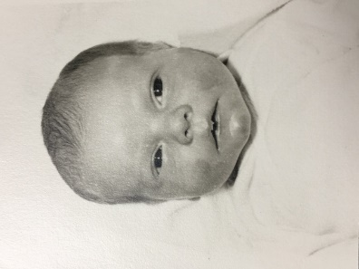

Andy after 18 hours in the world.